De Anza Courses and Teacher Ratings

**Summary:** A program to fetch class catalog from De Anza website and access them to get course data. These classes can then be saved to file and compared various ways via graphs.

1. **SQL database**Courses: CRN, course number, course name, teacher ID, date, time, seat status, department ID, units, prerequisites, description

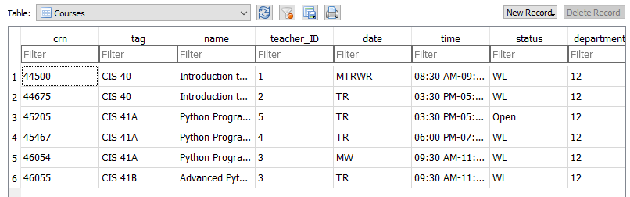

Departments: id, department abbreviation, department name

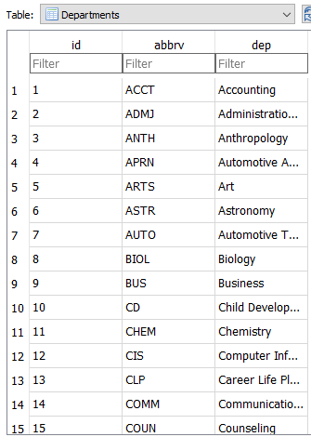

Teachers: id, full name

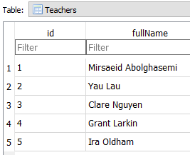

1. 64 De Anza departments * ~20 classes per department = 1280 classes in database
2. GUI will show data for classes sequentially, allowing user to narrow down search based on their desired department and exact class they want.  
     
   They can select the classes they want then either save it as their schedule to a txt file of their choice in their desired folder via System, graph the most popular department out of the selected departments, or graph the most popular class out of the selected courses.

Start: Show groupings of departments (Humanities, Sciences, Mathematics, etc.) **[MainWindow]**  
    |  
    |-- Select at least one group -> Show all Departments from selected groups **[Toplevel]**

|

|-- Choice: **Filter** (One or more filters applied) **for Choice 1**

||

| |-- Filter 1: Listbox to filter by seating status (Full, Waitlist, Open) with   
 | | selecting multiple status levels (Open+WL, Full+Waitlist+Open or   
 | | just None)

| |

| |-- Filter 2: Checkbutton to only show classes that occur on certain days  
 | | (MTWRFS). User can select/deselect on command.

| V  
          |-- Choice 1: Lists all courses available for selected departments -> Select at   
 | least one course from this list

| |

| |-- Choice 1: Save Schedule to File

| | |

| | |-- Brings up filedialog to ask user for file name, save   
 | | location, and whether to override existing preformatted   
 | | txt file with columns and extra line data.

| |  
     | |-- Choice 2: Compare Course popularity

| |  
 | |-- Bar chart with each selected course as an x-axis value   
 | and the y-axis is the number of similar classes   
 | (classes with the same course number i.e. CIS 40) in   
 | the department that are marked as “Full” or “WL”

|

|-- Choice 2: Compare selected departments popularity by percentage

| |

| |-- Bar chart with each selected department as an x-axis value and the   
 | y-axis is the percentage of classes in the department that are   
 | marked as “Full” or “WL”  
 |

|-- Choice 3: Compare all departments popularity by percentage

| |

| |-- Bar chart with each department as an x-axis value and the   
 | y-axis is the percentage of classes in all departments that are   
 | marked as “Full” or “WL” (shows which departments generally   
 | always have full classes  
 |

|-- Choice 4: Graph percentage of total offered courses by department (or   
 department group?)

|

|-- Bar horizontal chart showing what percentage of the school’s offered   
 courses are in which department (CIS offers 20% (200 CIS   
 classes/1000 total clases). Y-axis is department (group) names and   
 x-axis is percentage.

1. Maiah Pardo – Backend (Web scrapping, SQL database, threading)  
   Minh Pham – Frontend (GUI, Data visualization, System)  
   Both - Data Visualization (hurray for numpy)